

Technical Affairs, Public Works Authority

Engineering Business Department

**Tender and Contract Management System**

**(TCMS)**

For

Engineering Business Department

Release 1.0 | February 2019

Engineering Business Support Section | Engineering Business Department

As-Built Specification

**DOCUMENT CONTROL**

|  |  |  |  |
| --- | --- | --- | --- |
| **Document Title** | **Tender and Contract Management System**  **(TCMS) – Functional Specification** | | |
| **Document Number** | **EBD-PMIS-TCMS-001** | | |
| **Document Version** | 0.0.1 | **Release Date** | DD/MM/2018 |
| **Purpose** | *This document is intended for EBD internal use to document the specification of TCMS application* | | |
| **Document Owner** | **Manager of Engineering Business Department, Public Works Authority** | | |
|  |  | **Classification** | Internal Use Only |

**Document and Version Control**

|  |  |  |  |
| --- | --- | --- | --- |
| **Version** | **Amendment Description** | **Issue Date** | **Planned Revision Date** |
| 1.0.0 | Working Version |  |  |
|  |  |  |  |
|  |  |  |  |
|  |  |  |  |

***Disclaimer:*** *The official current version of this document is available on EBD shared Document Repository on the server with a read only access. Printout and saved versions are valid only for the particular use intended. Any other copy or version(s) or reproduction(s) of this document are considered invalid and void.*



Approvals

Reviewed By

|  |  |  |  |  |
| --- | --- | --- | --- | --- |
| **No.** | **Title** | **Name** | **Signature** | **Date** |
|  |  |  |  |  |
|  |  |  |  |  |
|  |  |  |  |  |
|  |  |  |  |  |
|  |  |  |  |  |
|  |  |  |  |  |
|  |  |  |  |  |

Approved By

………………………………………………………..

Management Office

Name & Signature Date: dd/mm/yyyy

………………………………………………………..

Manager of Engineering Business Department

Technical Affairs, Public Works Authority.

Name & Signature Date: dd/mm/yyyy

**TABLE OF CONTENT**

Approvals 3

GLOSSARY OF TERMS 6

LIST OF TABLES 7

EXECUTIVE SUMMARY 8

1. INTRODUCTION 9

1.1 Scope and Objectives 9

1.2 Document Owner 9

1.3 Context 9

1.4 References 9

2. BUSSINESS FUNCTIONS 10

2.1 Functional 10

2.2 Users Profile and Access Control List 13

2.3 System Functions 13

2.4 Integrated Systems 13

3. DATABASE DESIGN 14

3.1 Data Model 14

4. DEPLOYMMENT 15

4.1 Hardware Specification 15

4.2 Deployment Architecture 15

4.3 Database Configuration 15

4.4 Pre-Requisites 15

4.5 Client Requirements 15

4.6 System Configuration 16

5. Enhancements 17

5.1 Background 17

5.2 List of Enhancement 17

6. Known Issues 18

APPENDICES 19

GLOSSARY OF TERMS

The following table lists the abbreviation and definitions of terms referenced throughout the guide:

|  |  |
| --- | --- |
| EBD | Engineering Business Department |
| TCMS | Tender and Contract Managements Systems |
| CD | Contract Department |
| DM | Data Model |
|  |  |
|  |  |
|  |  |
|  |  |

LIST OF TABLES

EXECUTIVE SUMMARY

1. INTRODUCTION

This document is intended to provide functional specification and as built design of Tender and contract management systems (TCMS) developed and maintained by Engineering Business Department (EBD).

* 1. Scope and Objectives

The scope of this document is to provide as-built specification of TCMS application as on February 2019. This document is a live document, and owner of this document shall continuously update whenever there are changes to the solutions and its configuration.

The key objective of this document is:

* To provide business scope of the application
* To help the developer and administrator able to understand the solutions and continue to administrate the application.
  1. Document Owner

The TCMS Administrator is owner of this document.

* 1. Context

The context will provide organization’s relevance and plan the scope of the initiative and develop common language of audit control and risk management.

* TCMS software enables the user to create the project and update the data related to different stages of the project. For example, Prepare Tender Document, Tendering, Tender Evaluation and Award, Contract Process and Post Contract stage.
* There are admin and non-admin users in TCMS application.
* The admin user has the privilege to create other users and assign different types of access rights. For example, to access specific stages and modules of the project.
* There are four types of modules in TCMS Admin, Contacts, Projects and Reports.
* Inside Admin module there are four sub-modules. For example, Users, Security Profiles, Security Codes, and Email Alerts.
* Users module can enable user to “Add User”, “Edit User” and
  1. References

1. BUSSINESS FUNCTIONS
   1. Functional

|  | Advantages and Benefits of Using TCMS | Comparison with Old method of recording and updating of Report in Excel format |
| --- | --- | --- |
| Advantages and reliability in entering and preserving records. | | |
| 1 | Historical records of a particular project from all sections of Contract Department are all preserved from Tender Preparation Stage up to Contract Close out | Preservation of records in all Sections is not possible since every sections maintain their individual records. |
| 2 | Errors in entering actual dates are eliminated because validation and prompt message for wrong data entry are included in the feature. | Prone to errors in entering actual dates since validation is not applied |
| 3 | Interactive and user friendly features to ease the method of updating project information is present in the system. | Not applicable in old system. |
| 4 | Update in every status of the project are automated and errors are eliminated. | Update in the status are manually done and prone to errors |
| 5 | Historical records of how data are entered in the system can be traced. | Not applicable in old system. |
| 6 | No more excel file to save the records since all data resides in database which can be exported to excel file any time. | All data are kept in excel files form different computers. |
| Benefits in dissemination of information. | | |
| 1 | Access to project information and its related documents are readily available to view in real time. | Immediate access to project Information and its related documents in all Sections is not possible in the old system since every sections maintain their individual records. |
| 2 | Over all status and current load of Contracts Department are automatically updated in real time and is graphically represented in Dashboard. | Not available in old system. |
| 3 | Tender Status of every project are automatically updated and is always available to view in real time. | Not available in old system. |
| Benefits in Collaboration. | | |
| 1 | Collaboration in all sections and departments in ASHGHAL are maximized since all are viewing the latest updated information in real time. | Collaboration is inefficient. |
| 2 | Automatic email alerts can be customized to inform any user about the required information that he/she must be aware of any time. | Not applicable in old system. |
| 3 | Projects with issues related to tender bond validity that require immediate attention are filtered and listed separately in the system and is available in real time. | Not applicable in old system. |
| 4 | Automatic email alerts for all projects where tender bond validity will expire within 20 days are sent to all respective users. | Not available in old system. |
| 5 | Document control system that filters the documents that require attention is ready for immediate access. | Not applicable in old system. |
| Benefits in ease of using the system. | | |
| 1 | Man-hour consumed in entering data will be limited to one user only  since every data entered by one user is used by all concerned. | Every employee in any section who maintain the report and who needs to prepare a report have to type all the records. |
| 2 | Manual typing of entered information in the system is eliminated and dropdown list instead is provided. Example is in entering bidders. | Not applicable in old system. |
| 3 | Duplication of task in entering records/information are eliminated since record is entered once only and can be used by other users. | Every information was typed individually by all who maintained a separate excel files. |
| 4 | Searching for project specific information is efficient since data resides in one location (database). | Not applicable in old system since project information are dispersed from different sections. |
| 5 | Access rights to view/edit any information are customizable. | Not applicable in old system. |
| Benefits in preparation of reports. | | |
| 1 | Updated reports of any type are readily available at any time | Not applicable in old system. |
| 2 | Man-hours consumed in preparing of reports of any section / Department will be at the minimum. | There is always a need to follow up to concerned person who prepares the report in the old system. |
| 3 | Concise and up to date real time reporting is available any time. | Not applicable in old system. |
| Benefits in Automation. | | |
| 1 | Assigning of Tender number are generated automatically and format is uniform and will be communicated automatically thru email to every concerned section/Users. | Tender number assignment is manually assigned and needs to be manually communicated in every section of Contracts Department. |
| 2 | Transfer from one tender committee to another is automated to assign a new tender number for the new committee and information are automatically sent to all concerned regarding the transfer. | Information regarding the transfer is manually communicated to other staff and records are not reliable. |
| 3 | Original Records and documents of a project that was transferred from one committee to another are preserved. | Not applicable in old system. |
| 4 | Receipt vouchers are now automatically printed with out typing the required information in the form. | Manual typing and printing for every bidder. |
| 5 | Sending of circulars via email automatically copy all emails of contractors in one click of a button | Manual copy and paste of every email address of a bidder in the address box which is prone to error. |
| 6 | Integration with other database such as MOAZANAH and P6  Budget database automatically updates the reports of other departments of ASHGHAL | Not applicable in old system. |
| Benefits in Managing the Department. | | |
| 1 | Who and Who do not do their job assigned can be traced in the system. | Not applicable in old system. |
| 2 | Status and current load of each section of Contracts Department are dynamic and ready for viewing in Dashboard | Not available in old system. |
| 3 | Current load of assigned staff are clearly identified showing who has more load compared to others. | Not available in old system. |

* 1. Users Profile and Access Control List

The details of users profile and access control list are provide in the appendix as stated below.

1. List of registered users currently available in the system is provided in Appendix 2: User List
2. List of user profiles available in the system is provide in Appendix 3: Profile Info.
3. List of access rights profile available in the system is provided in Appendix 4: Access Rights
   1. System Functions

There are four types of systems/modules in TCMS Admin, Contacts, Projects and Reports.

* 1. Integrated Systems

1. DATABASE DESIGN

This section describes the database design for the production TCMS database.

* 1. Data Model

The physical data model of the production system is provided in the **Appendix 1: Data Model.** The data model provide the logical model for the TCMS database, and shows only primary and foreign keys.

1. DEPLOYMMENT

TCMS is a windows application developed with client/server architecture, using Microsoft C# .NET (Framework 3.5) and SQL Server 2008 database software products.

* 1. Hardware Specification
  2. Deployment Architecture

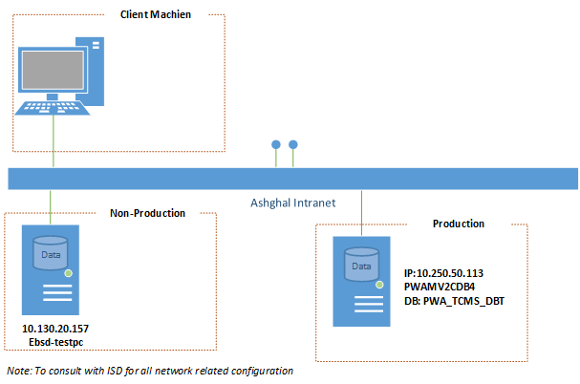

Figure 1 TCMS Deployment Architecture

* 1. Database Configuration

The following screenshot shows the current of TCMS Production database configuration.

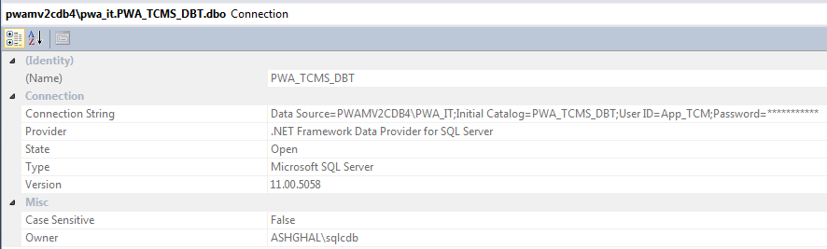

Figure 2 Current TCMS Production Database Configuration

* 1. Pre-Requisites

TCMS is a windows application developed using Microsoft C# .NET (Framework 3.5) and SQL Server 2008 database software products.

* 1. Client Requirements
  2. System Configuration

1. Enhancements
   1. Background

This section provides list of enhancement requirements and its status.

* 1. List of Enhancement

| #. | Enhancement Name & Description | Requesting Department | Requested By | Status |
| --- | --- | --- | --- | --- |
| 1 | **VO/SI Information**  *To able to capture information related to VO, Addendum, SI in TCMS and provide a notification system for SI alerts for SLA adherence* | Contract Department | Mohammed Riyas Tazi | Not started. |

1. Known Issues
   1. Experience Slowness while retrieving the data from the TCM database by the TCM application.

*Resolved the problem by modifying the functions which retrieves data from the joined tables using the SQL queries. Modified the way of retrieving data, instead of completely relying on joined SQL queries. I have break up the SQL queries into many small queries which executes on a single table. After that I am joining the tables by using LINQ and retrieving the data into the DataTable object of C#.NET.*

*By increasing the time to execute the SQL queries within the application and created cluster indexes on the important tables in TCM database. For example, Projects, TenderDatesInfo, Contractors and Company.*

1. User Manual
   1. Modules and Functionalities Of Tender And Contract Management System (TCMS)
2. TCMS is a windows application developed using Microsoft C# .NET (Framework 3.5) and SQL Server 2008 database software products.
3. TCMS application enables the user to create the project and update the data related to different stages of the project. For example, Prepare Tender Document, Tendering, Tender Evaluation and Award, Contract Process and Post Contract stage.

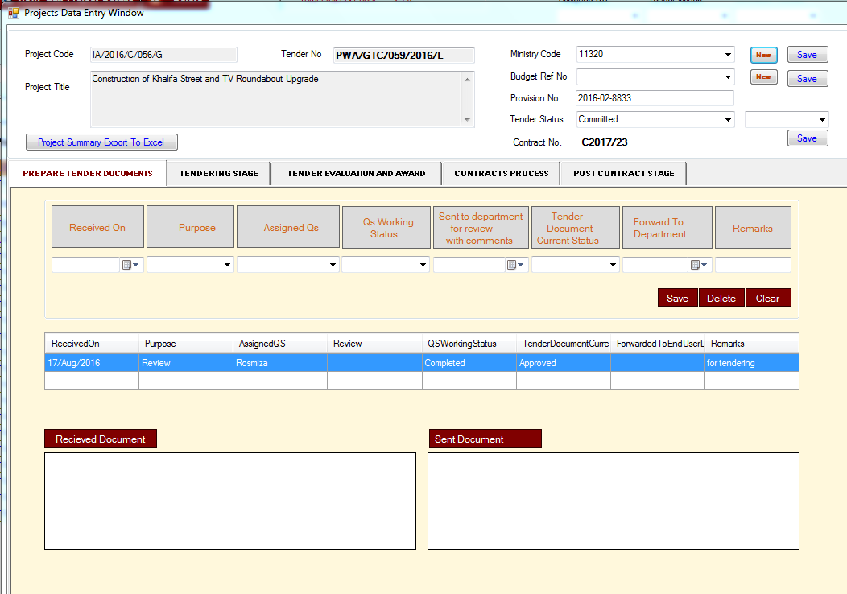

1. There are admin and non-admin users in TCMS application.

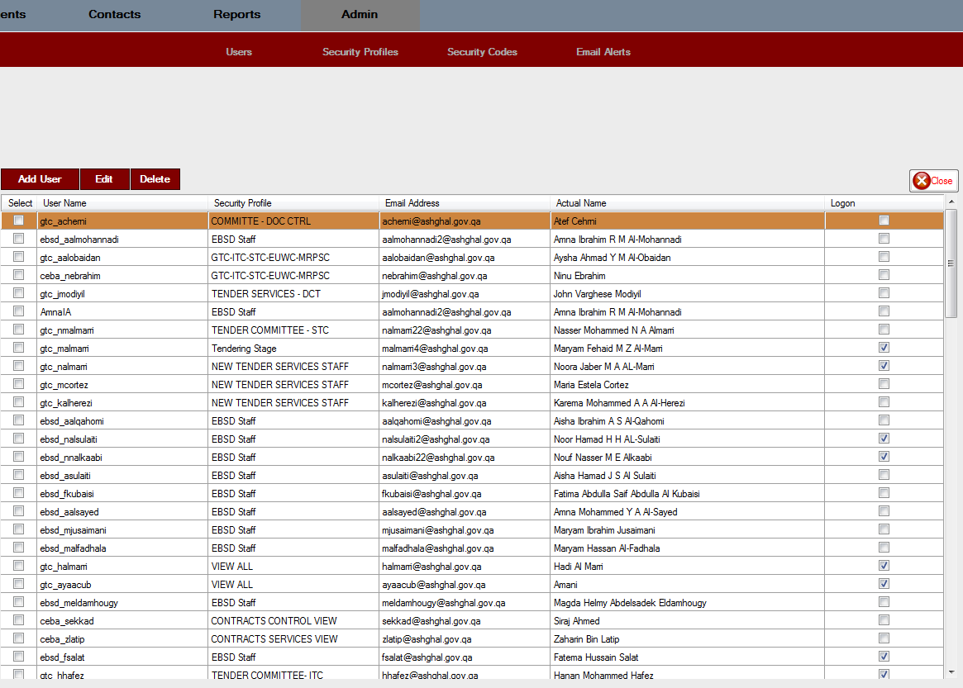

1. The admin user has the privilege to create other users and assign different types of access rights. For example, to access specific stages and modules of the project.
2. There are five types of modules in TCMS application, Admin, Contacts, Projects, Reports and Documents.



1. Inside Admin module there are four sub-modules. For example, Users, Security Profiles, Security Codes, and Email Alerts.



1. Users module can enable user to “Add User”, “Edit User”, “Delete User”, “Add Security Profiles”, “Update Security Profiles”, “Delete Security Profiles”, “Add/Edit Tender Types” and Add Users to different committees for receiving emails for “Tender Cancellation”, “Expiration of Evaluation”, “New Tender Number Assignment”, “Change in Tender Closing Date”, “Transfer of Tender To Another Committee” and “Expiration of Tender Validity” categories.
2. Report module consists of following twenty reports :-
   1. Tender Tracking Reports
   2. Tender Committee Reports
   3. Tender Committee Award
   4. Project Tracking Reports
   5. Tender Committee
   6. Tender Bond Tracking
   7. Committed Contracts
   8. Work Order Reports
   9. Qatari Share In Company
   10. Total Tender Approval Days
   11. Contractor Details
   12. Staff Job Tracking Details
   13. Awarded Tenders
   14. Contractor Qatari Share
   15. Company Participation In Different Tenders
   16. QS Working Status
   17. List Contracts
   18. Contract Values
   19. Projects Pre and Post Stage Records
   20. Companies Contracts Information

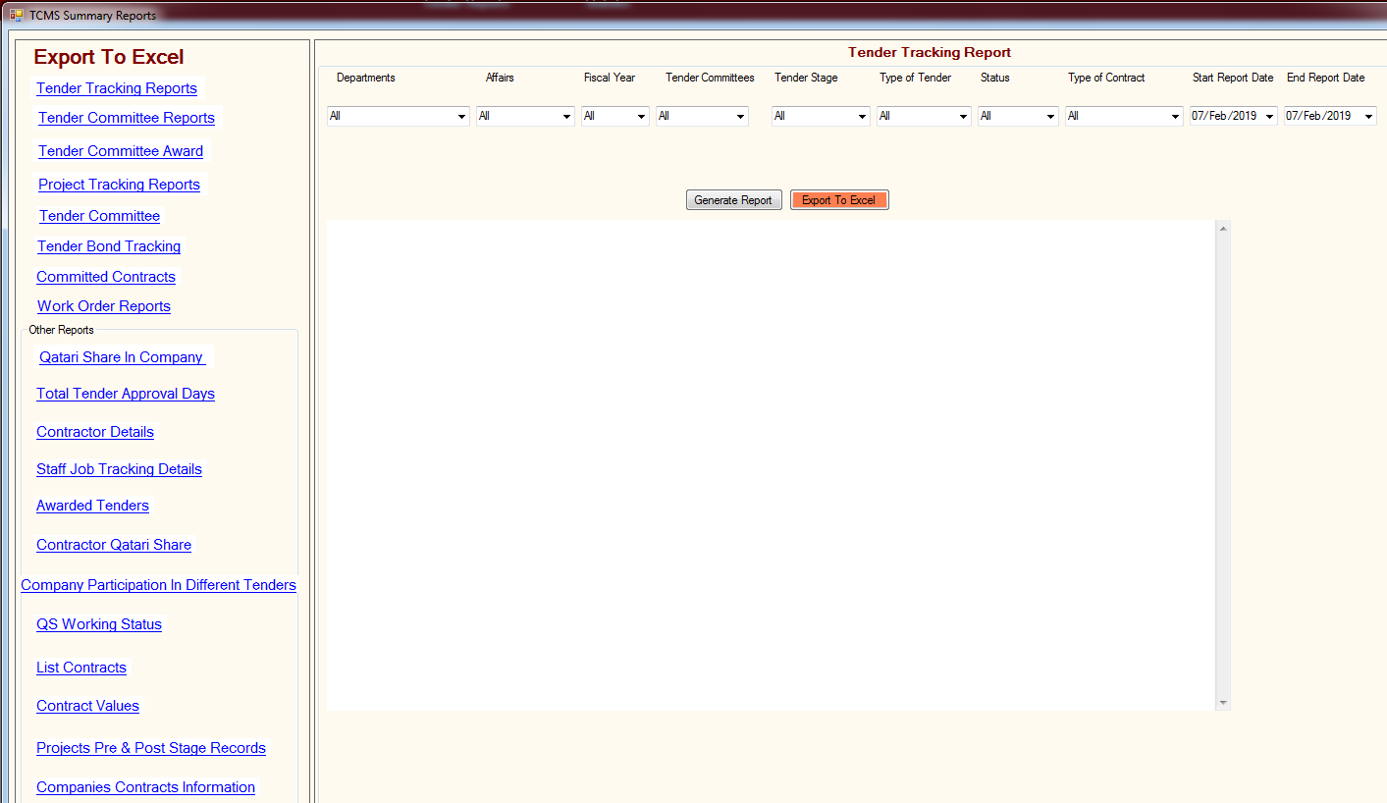

1. The above reports can be generated based on the different parameters provided by the user for example Department, Affairs, Fiscal Year, Tender Committees, Tender Stage, Type of Tender, Tender Status, Type of Contract and Start and End Report Date. User can export the reports in excel format.
2. Contacts module can enable user to Add, Edit, set the status of the company to active or in-active, Search the company and Export the companies information into an excel file.

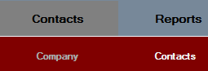

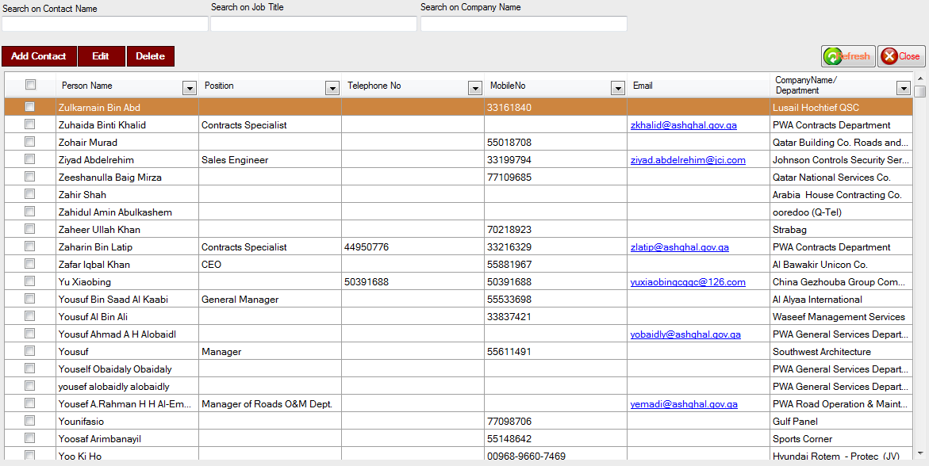

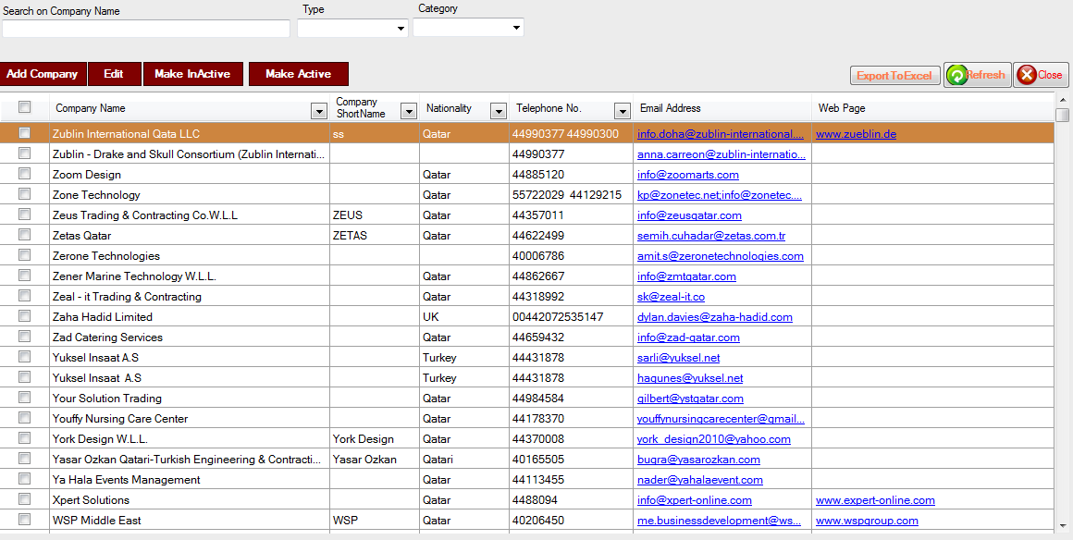

1. Contacts module can enable user to Add, Edit and Delete user information. Search Contact information based on Contact Name, Job Title and company name.
2. Documents module will display the list of all the documents (send and received) attached by the user in various projects. User can search the documents based on the Subject, Reference Number and Project Code.

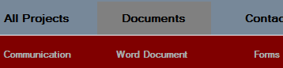

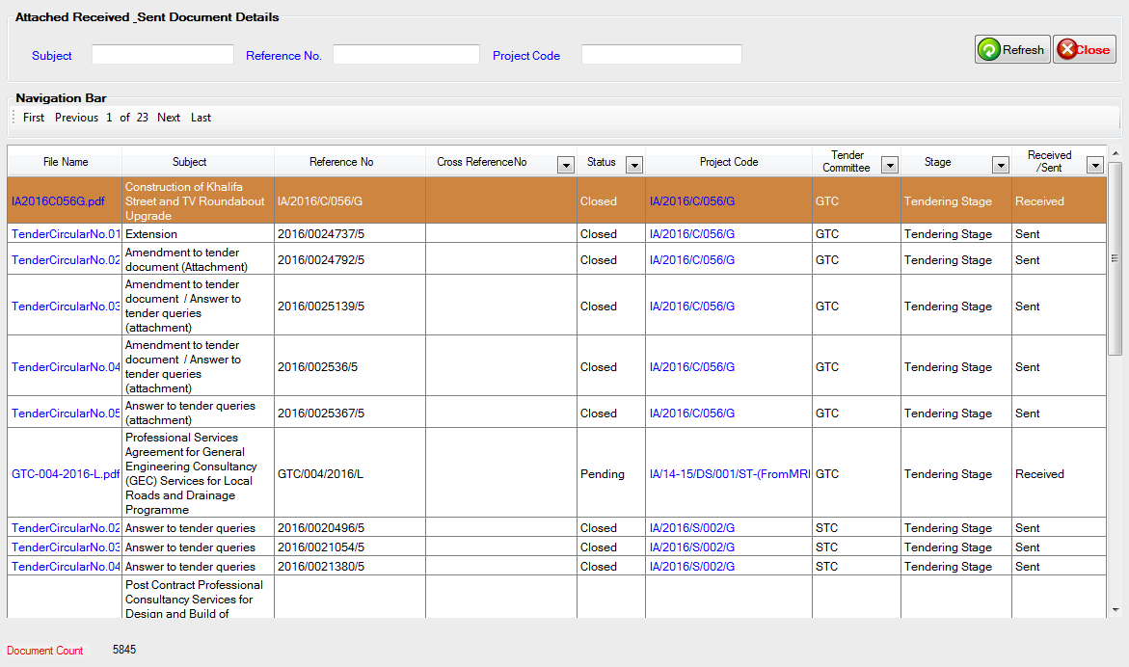

1. All Projects module consists of ten sub-modules namely Projects Group per Contract, Projects Group per Tender, View Successful Bidders, Ongoing Contracts, Inactive Contracts, Archives, Current Day Closing Tenders, One Month Back Closing Tenders, Running Tenders and Deleted Projects.



1. Projects module enable user to “Add New Project”, “View/Edit Project Details”, “Delete Project”, search projects based on Project Code, Project Title, Tender Number, Current Stage, Tender Status, Type of Tender, Tender Committee, Type of Contract, Contract Number, Fiscal Year, Department, MozanahID and assigned staff.

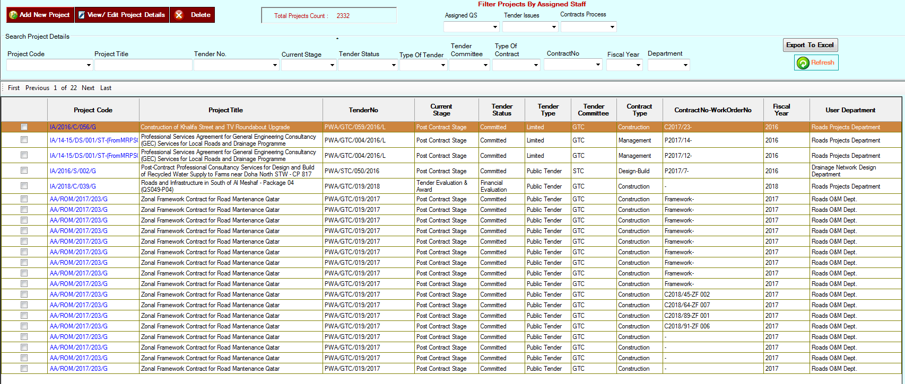

1. Projects Group per Contract will display all the projects based on particular access rights assigned to the user including Contract Number information per project.

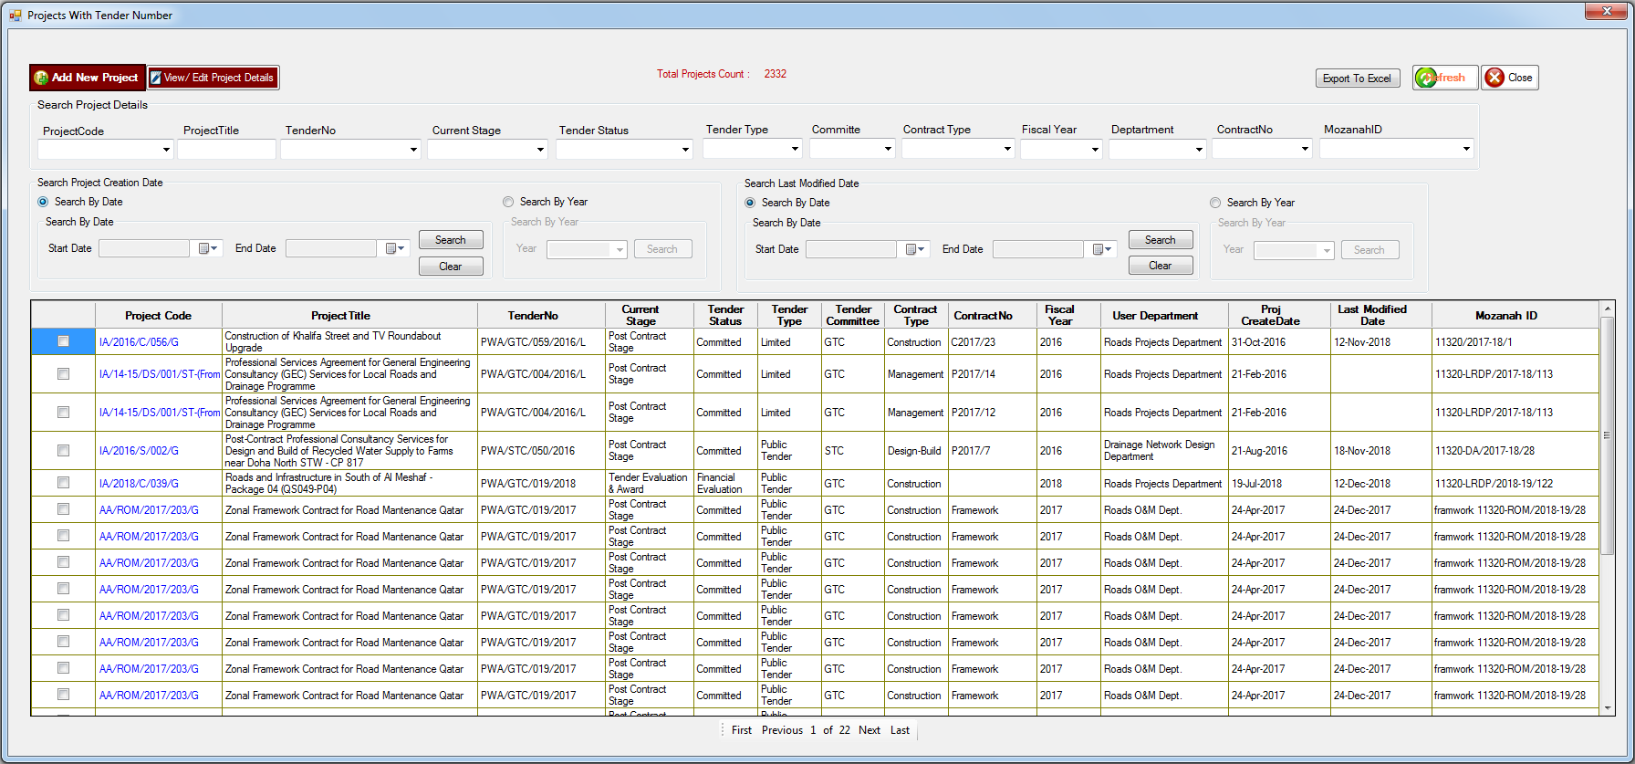

1. View Successful Bidders sub-module will display all the projects with Tender Status not equal to “Re-Tender”, “Transferred to Other Committee”, “Archive”, and the project is under “Contracts Process” or “Post Contract Stage”, and the Contract Number associated with the project should not be equal to “Framework” or “Work-Order”. By clicking on Project Code hyperlink user can open the project and navigate to “Tendering Stage”. User will click on “View Bidders” button to view the list of successful and rejected bidders.

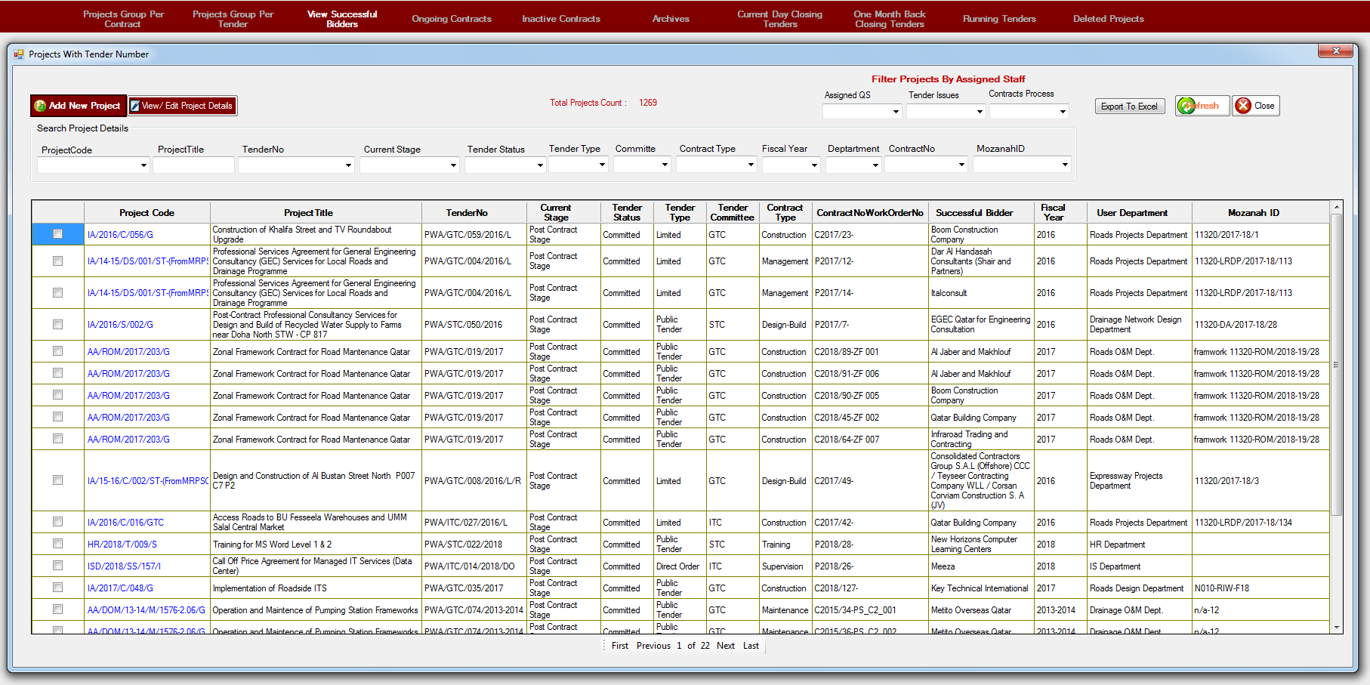

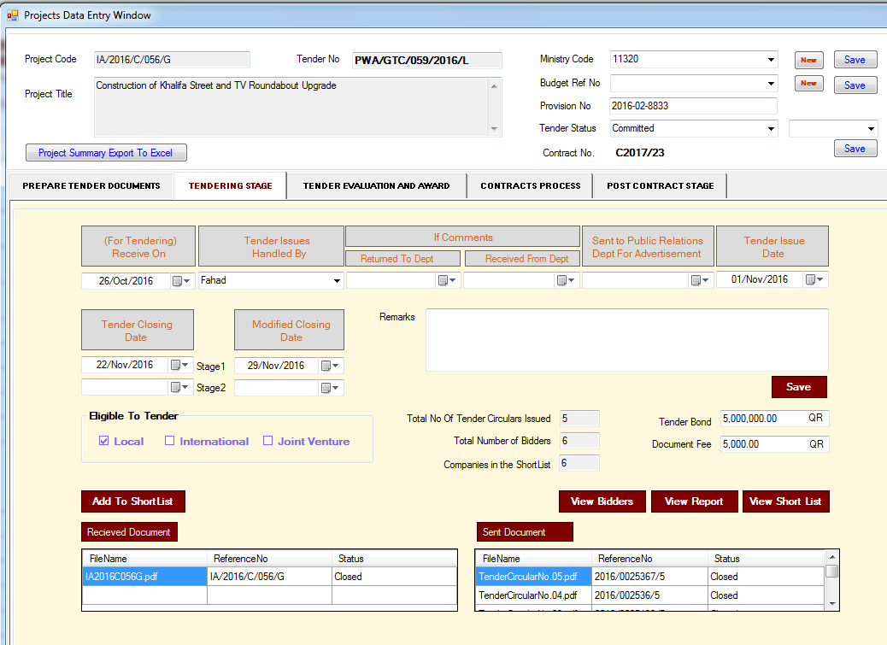

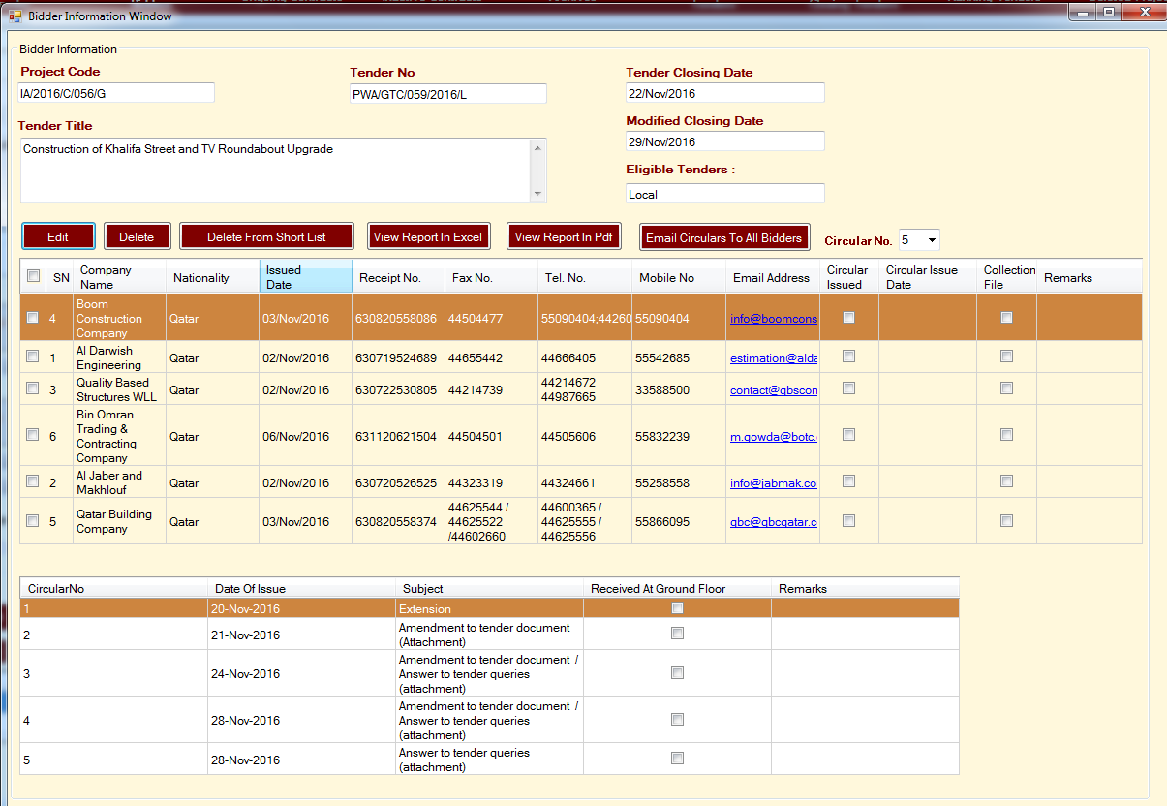

1. Ongoing Contracts sub-module will display all the projects with any Contractor whose status is On-going.

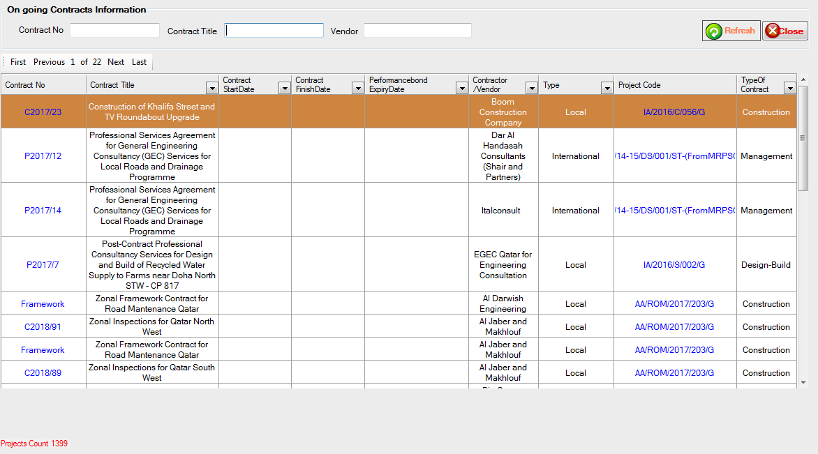

1. Inactive Contracts sub-module will display all the projects with any Contractor whose status is not On-going (or other than On-going).

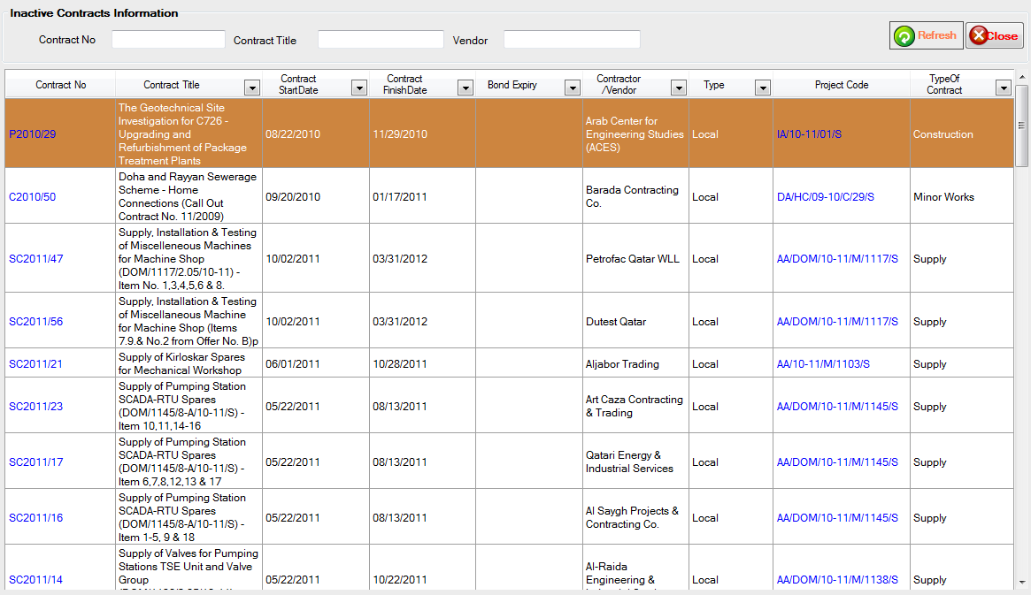

1. Archives sub-module will display all the projects whose status is Cancelled, Re-Tender, Transferred to Other Committee and Archive.

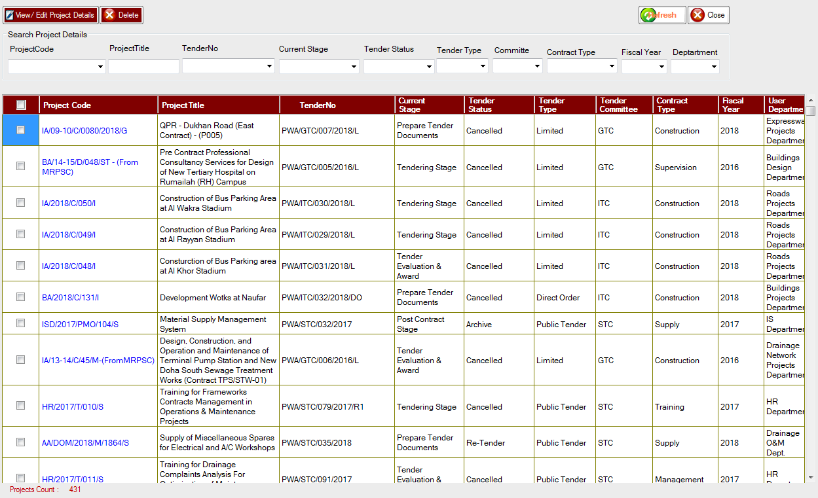

1. Current Day Closing Tenders sub-module will display all the projects whose Tender closing or modified date is current date or today’s date.

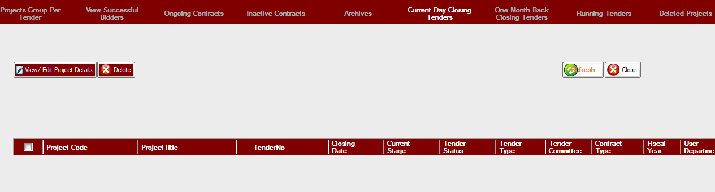

1. One Month Back Closing Tenders sub-module will display all the projects whose Tender closing or modified date comes under last one month.

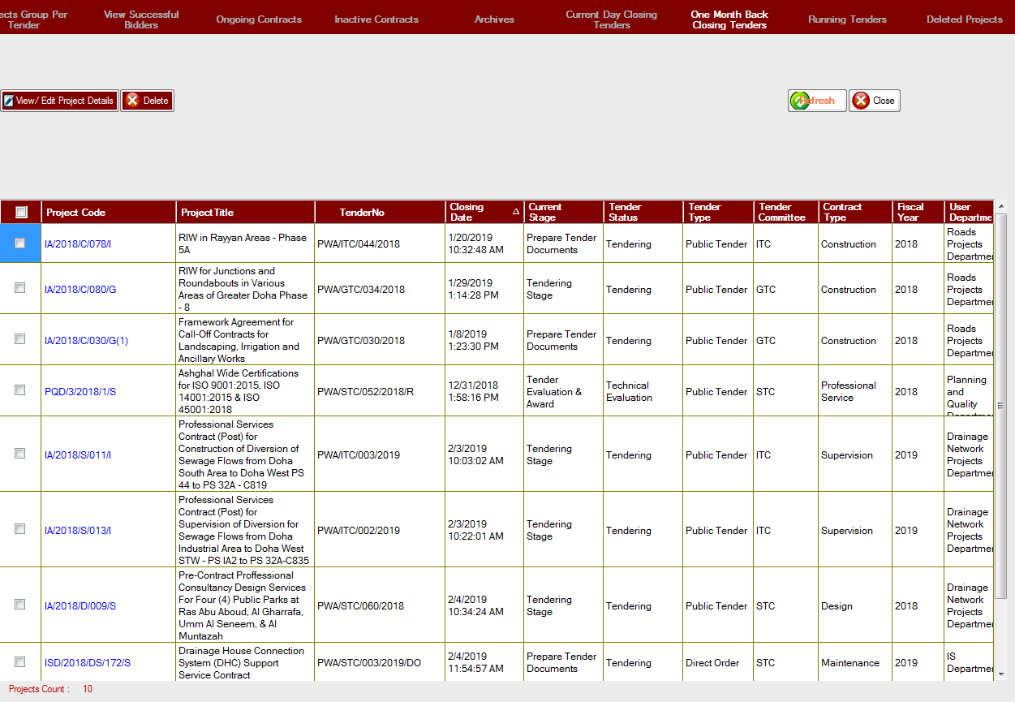

1. Running Tenders sub-module will display all the projects whose Tender closing or modified date is equal to or greater than today’s date.

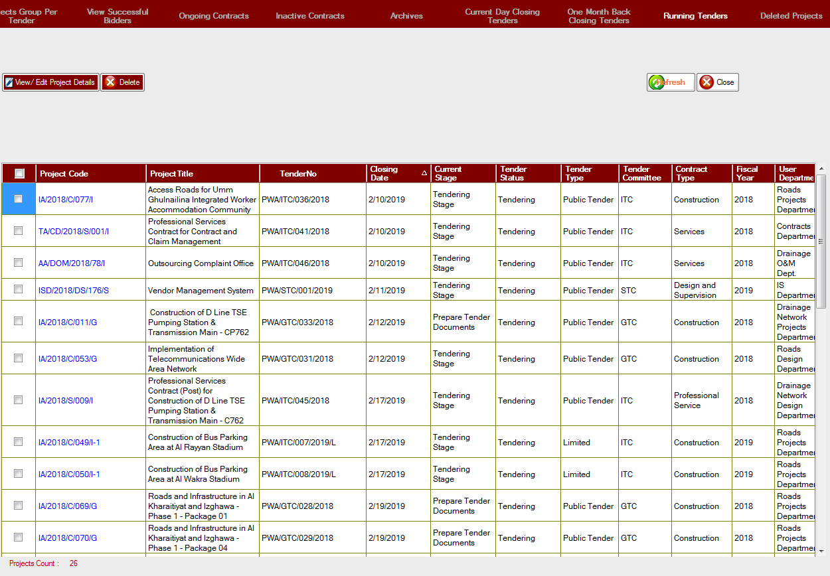

1. Deleted Projects sub-module will display all the projects whose “Is-Deleted” column value is set to one.

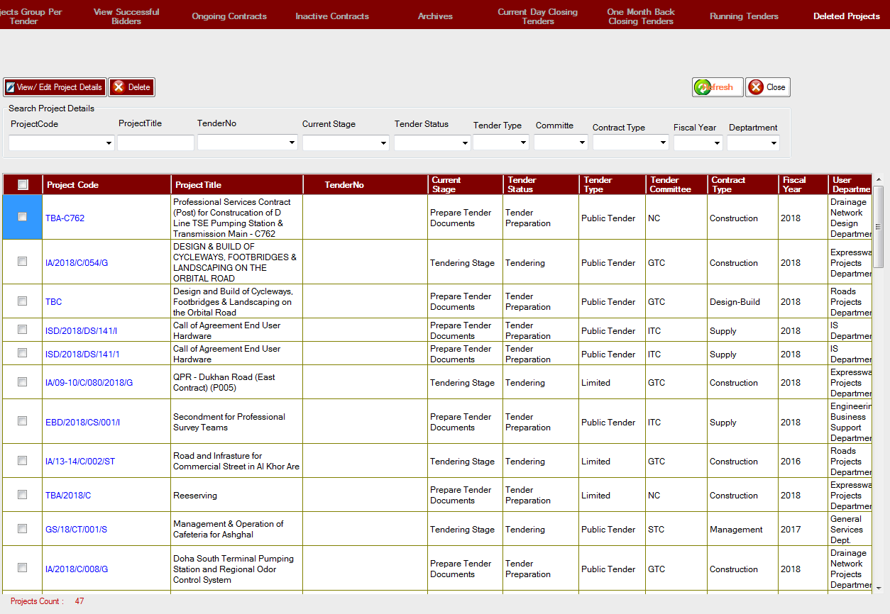

1. Dashboard of TCM consists of charts which display information for Number of Tender Documents Approved Each Year, Total Projects per Tender Status, Number of Tenders Each Year, Total Value of Tender Awards per Committee (QAR Millions), and Tender Documents under Preparation.

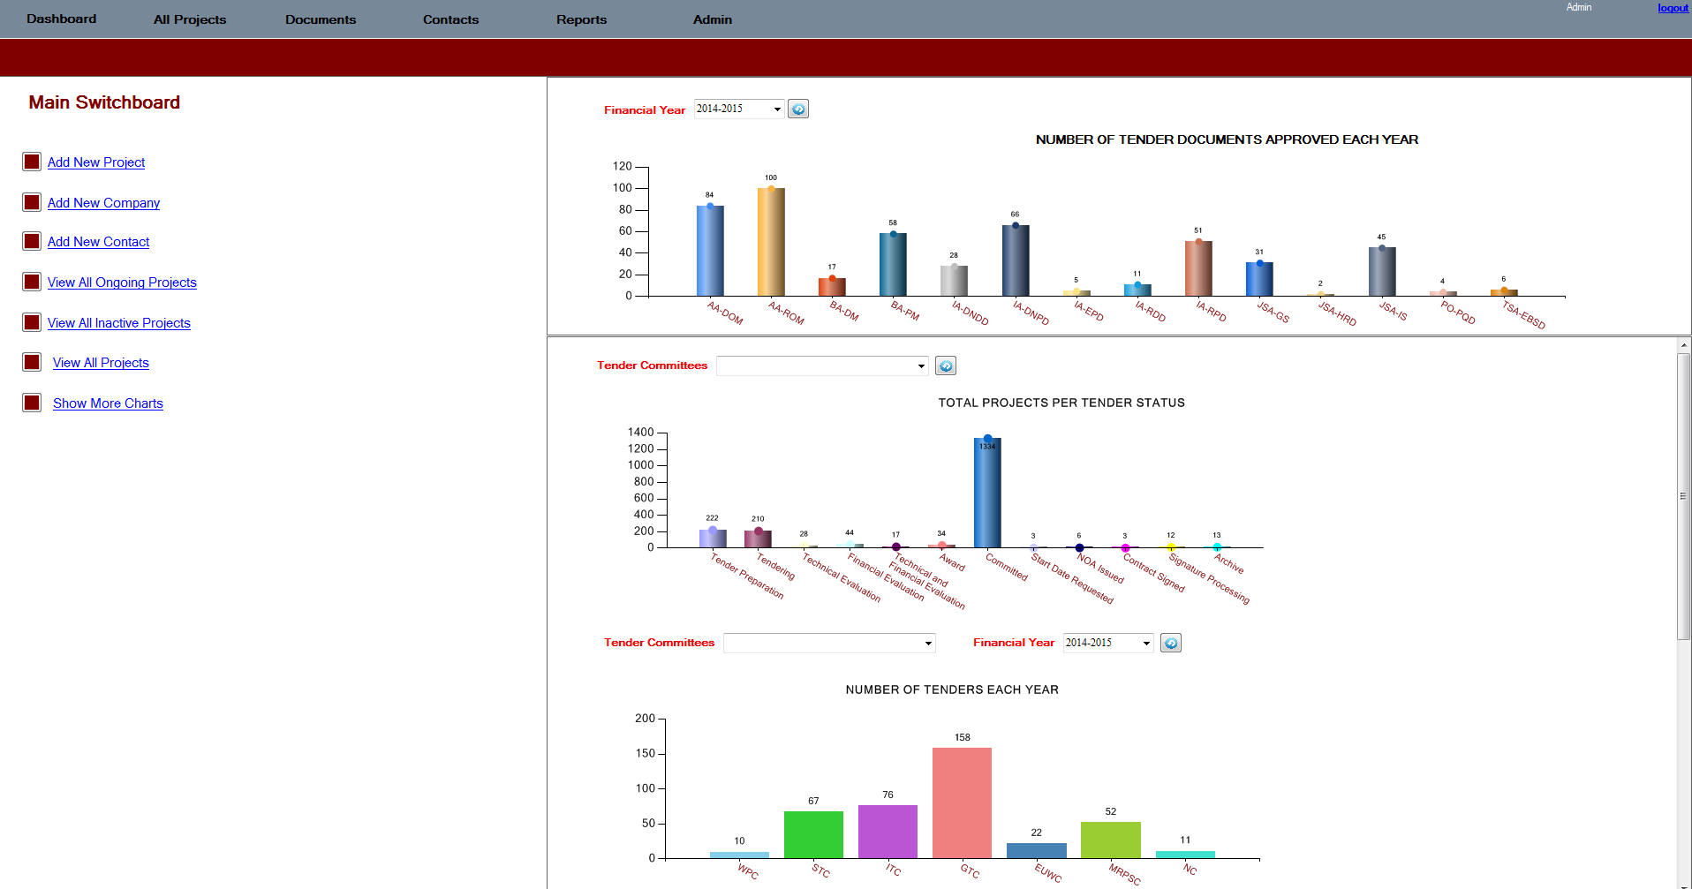

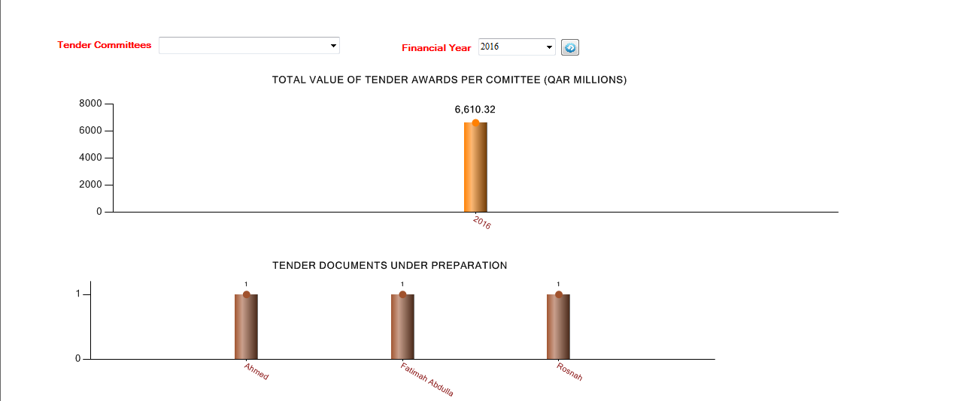

1. The Project in TCM application consists of five stages these are Prepare Tender Document, Tendering, Tender Evaluation and Award, Contracts Process and Post Contract stages.

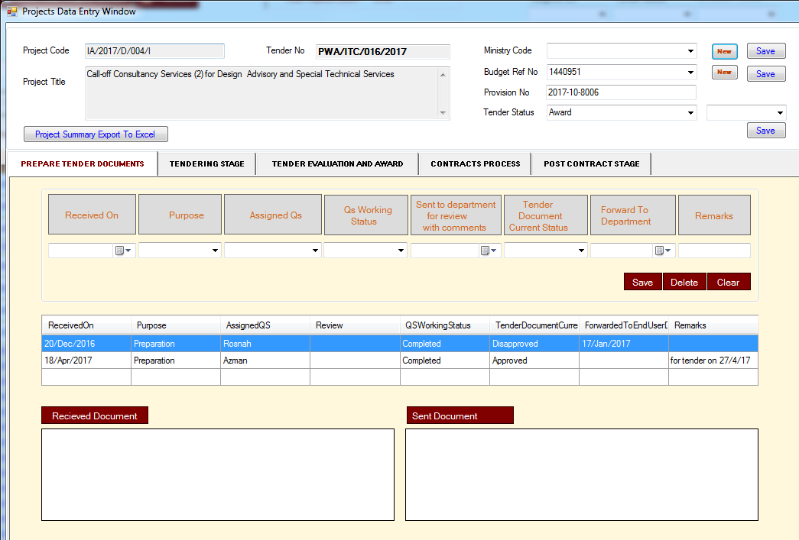

1. Except Post Contract stage, user can attach Send and Received documents. Prepare Tender Document stage allow user to enter Received-On date, Purpose, Assigned-QS, QS Working Status, Tender Document Current Status, Forward to Department and Remarks information.
2. Tendering stage allows user to enter Tendering Received On date, Tender Issued By, Comments from Department, Send to Public relations dept. for advertisement, Tender Issue Date, Tender closing and modified date, remarks, who is eligible for tendering (Local, International and Joint Venture), and Tender Bond and Document fees.

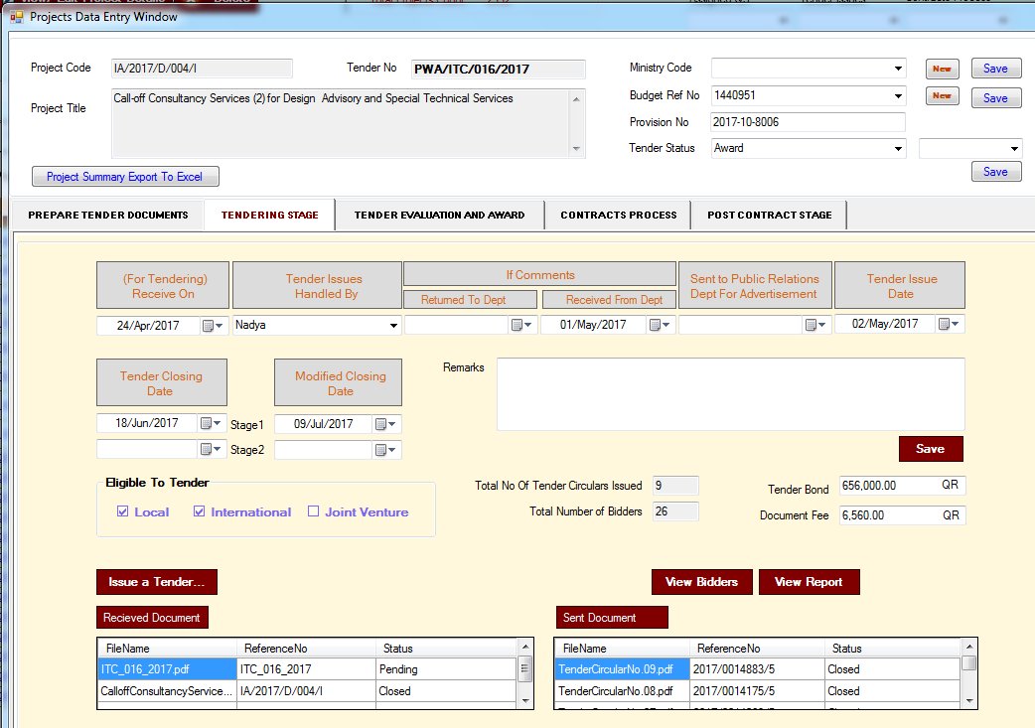

1. User can add bidders to the project from Tendering stage. By clicking on “Issue a Tender” button.
2. Users can view the details of added bidders by clicking on “View Bidders” button.
3. Users can also generate the report (Tender Collection) on the details of added bidders in pdf format by clicking on “View Report” button.
4. Inside the Window form of “View Bidders”, user can Edit or Delete the information of the bidders. However, Edition or Deletion operations, depends on access rights assign to the user.

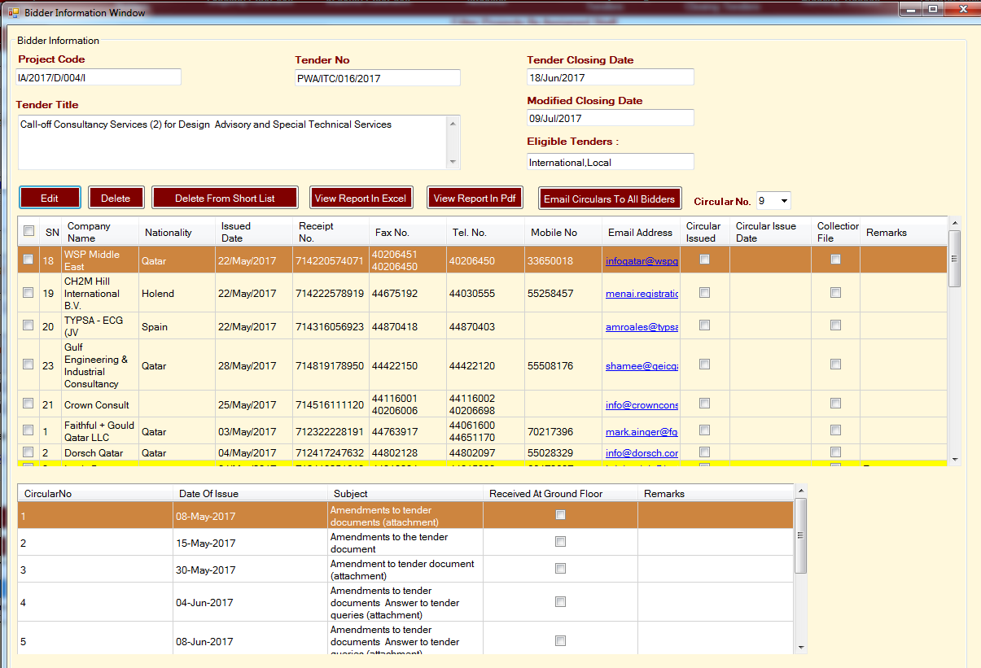

1. Through this form user can generate the report on bidders in excel and pdf formats.
2. Through this form user can Email Circulars to All Bidders.
3. There are six project types namely Public Tender, Direct Order, Limited, Re-Tender, Pre-Qualification and Auction.
4. Only for Direct Order and Limited projects both “View Bidders” and “View Short-List” functionalities are available. For other project types only “View Bidders” functionality is available.

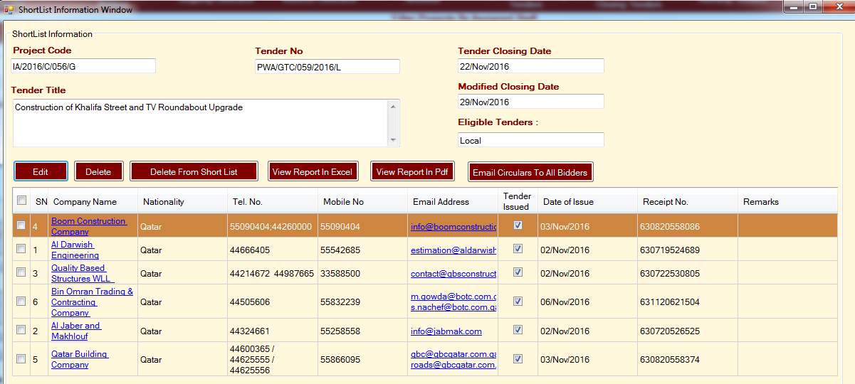

1. Information related to project’s Tender Evaluation and Award is entered through Tender Evaluation and Award stage.

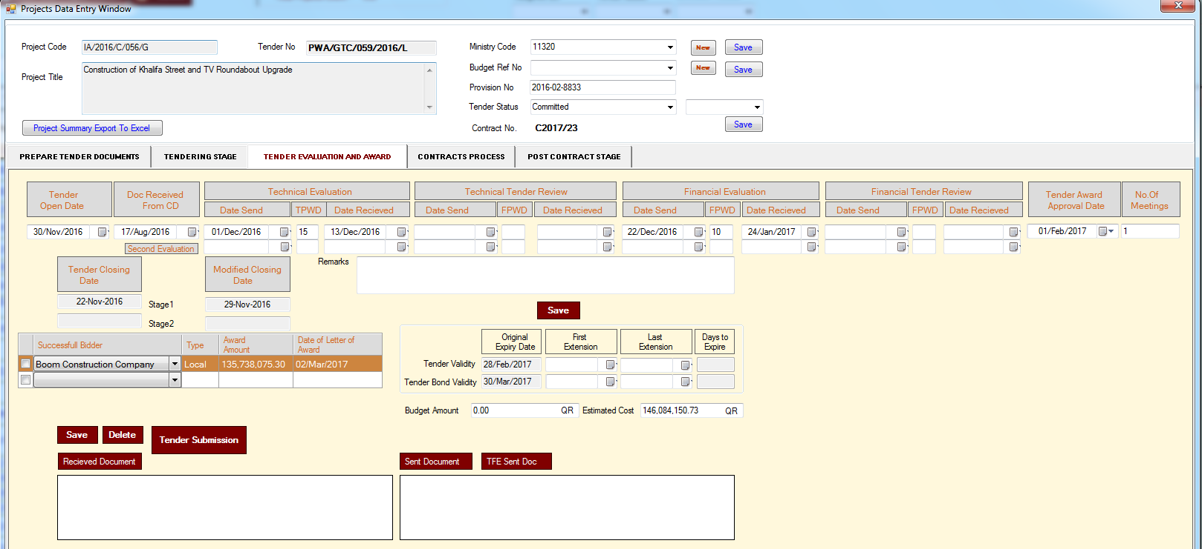

1. This stage contains Tender Open, Document Received from CD, Technical Evaluation, Technical Tender Review, Financial Evaluation, Financial Tender Review, Tender Award Approval, Tender closing and modified dates. It also contains Number of meetings, remarks, Tender Validity and Tender Bond Validity dates information. It also contains Successful bidder information, awarded amount, Date of letter of award, budget amount and estimated cost.
2. Tender Evaluation and Award stage enables user to enter information about the tender submission details related to bidders of the project. By clicking on “Tender Submission” button user can enter the details of the tender submission or re- submission by the bidders. TCM application will allow user to issue receipt of Tender Submission in pdf format to the bidder of the project.

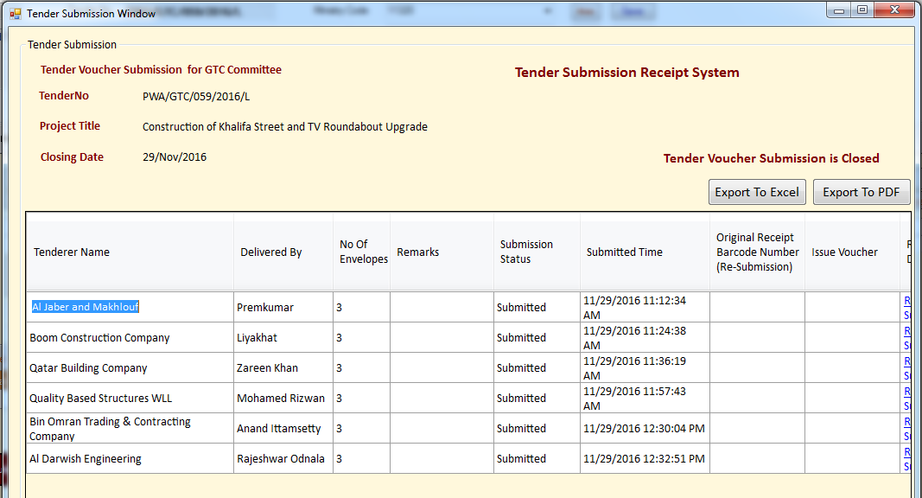

1. Based on access rights users of TCM application can also export the details of submission by the bidders in excel or pdf format.
2. From Tender Evaluation and Award stage based on access rights users can create new “Work Order” for the project. Work Orders are extra work related to the project. A work order may have a Contract Number associated with it.

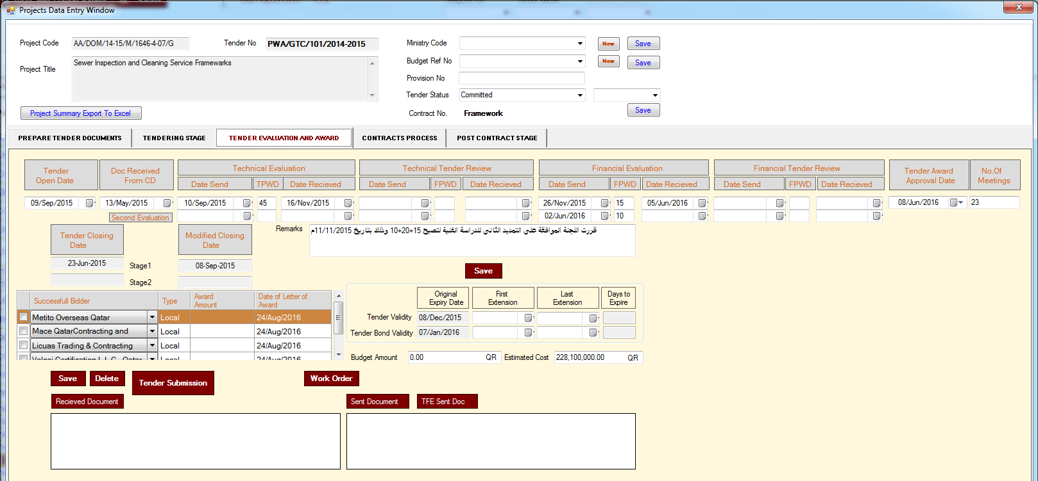

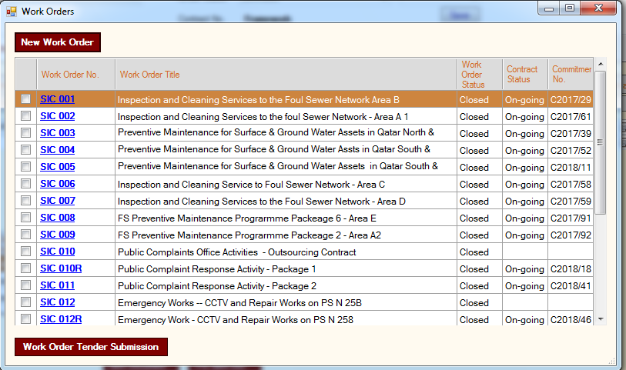

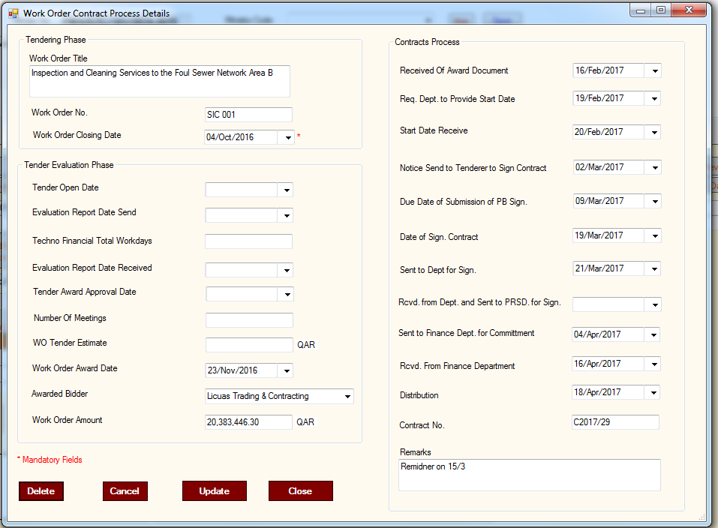

1. Based on access rights users can delete the work order. Similar to Tender Submission functionality user must issue tender submission receipt to the bidder of the “Work Order”. For that user has to select the work order and then click on the “Work Order Tender Submission” button.
2. Fourth stage of the project is “Contracts Process”. Through this stage user can enter Contracts Process information related to the specific bidders of the project. This include “Handled By”, “Received of Award Document”, “Request Department to provide start date”, “Start Date Received”, “Notice Send to Tenderer to Sign”, “Due Date of Submission of Bond and Sign”, “Date of Sign Contract”, “Sent to Dept. for Sign.” etc.

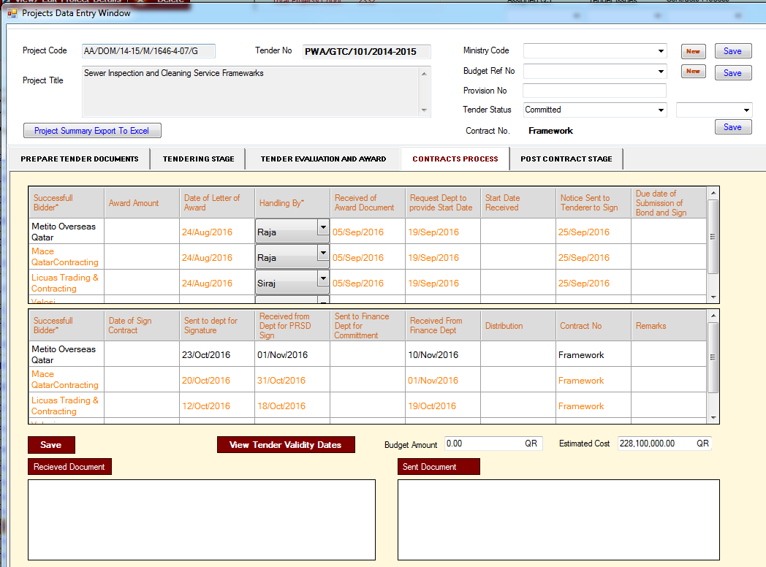

1. Fifth stage of the project is “Post Contract”. This stage contains addition information related to the bidders. For example Contract Start and Finish dates, performance bond expiry date and Contract Status.

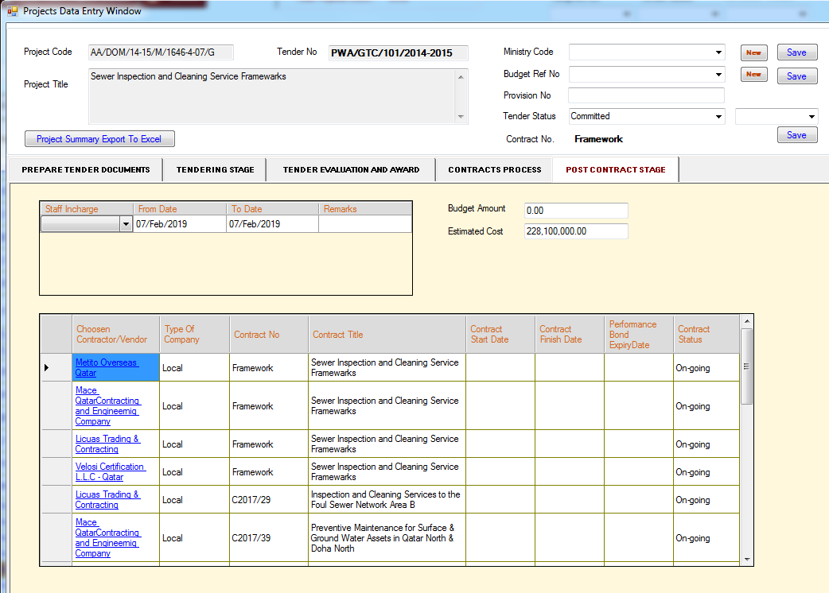

1. On the click of Bidder name a new window will open, which will allow user to add or edit the details related to the contract on which the successful bidder will work.

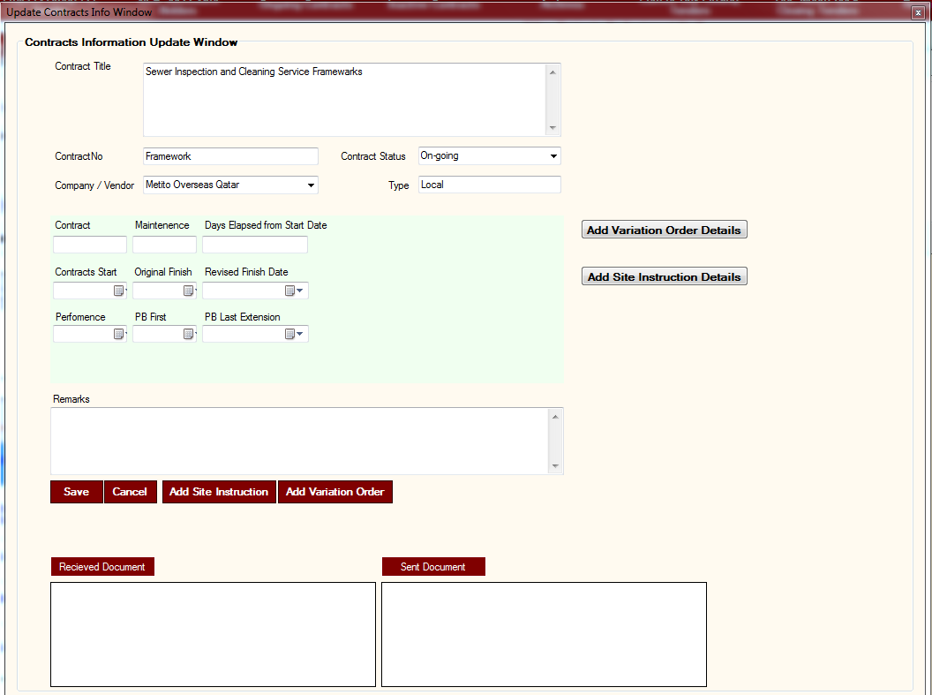

1. On the click of “Add Variation Order Details” button TCM application allows user to enter details related to variation order.

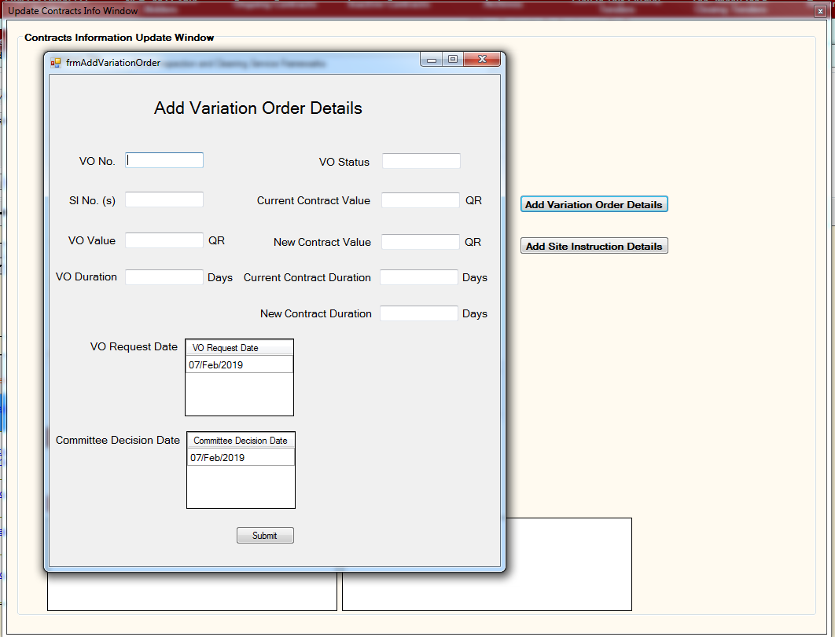

1. On the click of “Add Site Instruction Details” button TCM application allows user to enter details related to site instruction.

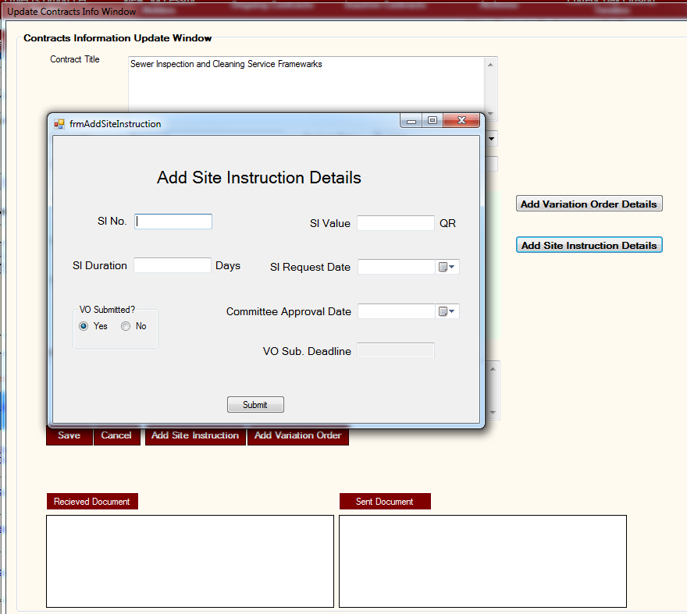

1. User can export the Summary of all the five stages of the project in excel sheet.
2. Based on access rights users can assign Ministry Code, Budget Ref. Number and Provision Number.

APPENDICES

1. Data Model

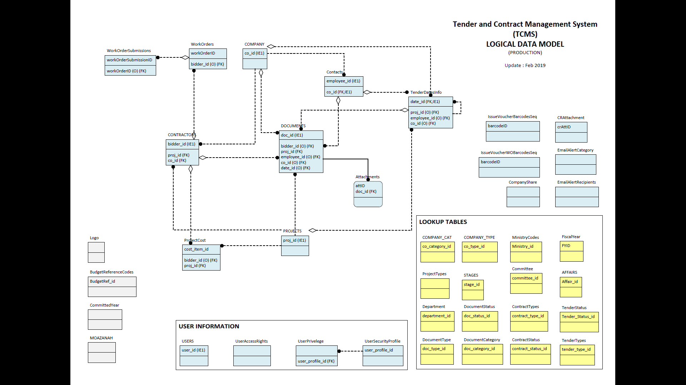

1. User List

| **user_id** | **user_profile_id** | **user_name** | **email_address** | **actual_name** |
| --- | --- | --- | --- | --- |
| 1 | 1 | admin | mriyas@ashghal.gov.qa | Administrator |
| 2 | 1 | ceba_galmansoori | galmansoori@ashghal.gov.qa | Ghanem Rashid Al-Mansoori |
| 3 | 12 | ceba_myazeedi | malyazeedi@ashghal.gov.qa | Mohamed Yahya Saleh A Al-Yazidi |
| 4 | 2 | ceba_sjoy | sjoe@ashghal.gov.qa | Sam Joy |
| 5 | 22 | ceba_nalmarri | nalmarri@ashghal.gov.qa | Noora Mohammed S B Al Marri |
| 6 | 30 | gtc_hhafez | hhafez@ashghal.gov.qa | Hanan Mohammad Abdulhafez Mohamed |
| 7 | 17 | ceba_asabry | asabry@ashghal.gov.qa | Ahmed Sabrie Siad |
| 8 | 33 | pwa_mobaidly | mobaidly@ashghal.gov.qa | Manal Mohd Mohd Salem Al-Obaidly |
| 9 | 4 | ceba_niqbal | niqbal@ashghal.gov.qa | Nadeem Iqbal Mohammad Iqbal |
| 10 | 1 | ceba_fharab | fharab@ashghal.gov.qa | Fady I H Abdaljawwad |
| 11 | 19 | ceba_amarri | ajaib@ashghal.gov.qa | Ajayab Abdulla H A Al-Marri |
| 12 | 31 | gtc_nashwa | nashwa@ashghal.gov.qa | Nashwa Mohsen Mohamed Hasan |
| 13 | 29 | gtc_sramli | sramli@ashghal.gov.qa | Safaa Ramli Mohammed |
| 14 | 1 | ceba_mriyas | mriyas@ashghal.gov.qa | Mohammed Riyas T C |
| 16 | 1 | ebsd_svadakapuram | svadakapuram@ashghal.gov.qa | Sreedhar V |
| 17 | 5 | ebsd_nkumar | nkumar@ashghal.gov.qa | Nithin Kumar |
| 18 | 17 | tsd_sabdulkader | tsd_sadulkader@ashghal.gov.qa | Sharaf Abdulkader |
| 23 | 7 | ceba_abasheer | abasheer@ashghal.gov.qa | Abdul Basheer |
| 25 | 12 | ceba_smoussa | smoussa@ashghal.gov.qa | Sara Moussa |
| 26 | 22 | gtc_mdawi | mdawi@ashghal.gov.qa | Mariam Farag Dawi Al Sultan |
| 27 | 12 | ceba_almirri | almirri@ashghal.gov.qa | Fahad Mohammed A S Al Marri |
| 28 | 7 | ceba_mfaisal | mfaisal@ashghal.gov.qa | Maliyakkal Muhammed Faizal |
| 29 | 5 | tsd_nbalamohan | nbalamohan@ashghal.gov.qa | Balamohan |
| 30 | 5 | tsd_wabdelsalam | wabdelsalam@ashghal.gov.qa | Walid Mohamed Samir Abdel Salam |
| 31 | 2 | ceba_rafat | rafat@ashghal.gov.qa | Rafat Perween |
| 32 | 1 | Administrator | tcms@ashghal.gov.qa | TCMS |
| 33 | 33 | Ltc_jshehadeh | Jshehadeh@ashghal.gov.qa | Juhanh Ali Abedallateef Shehadeh |
| 34 | 19 | Ltc_ahajar | ahajjar@ashghal.gov.qa | Asad Ibrahim Asad Hajjar |
| 35 | 20 | gtc_nkhatabiyah | nkhatabiyah@ashghal.gov.qa | Nouh Ahmed Mohammad Khataybeh |
| 36 | 25 | gtc_rmarmar | rmarmar@ashghal.gov.qa | Rima Kassem Marmar |
| 39 | 5 | ebsd_vpuchnanda | vpuchnanda@ashghal.gov.qa | Varun Puchnanda |
| 40 | 12 | ceba_nzainal | nzainal@ashghal.gov.qa | Nadya Zainal |
| 41 | 12 | ceba_nmajid | nmajid@ashghal.gov.qa | Nawal Majid |
| 42 | 10 | ba_ahassan | ahassan@ashghal.gov.qa | Abdel Hamid Mohammed Mohd Hassan |
| 43 | 41 | ceba_nravi | N.ravi@ashghal.gov.qa | Ravi Balan |
| 44 | 4 | ceba_fnazar | fnazar@ashghal.gov.qa | Fathima Nazar |
| 47 | 5 | ebsd_mamustafa | mamustafa@ashghal.gov.qa | Muhamad Akmal Bin Mustafa |
| 48 | 5 | ebsd_ijibahi | ijibahi@ashghal.gov.qa | Inaya |
| 49 | 5 | ebsd_asaret | asaret@ashghal.gov.qa | Arnel Saret |
| 51 | 36 | ceba_alateef | alateef@ashghal.gov.qa | Abdul Latheef |
| 52 | 9 | cd_mjani | mjani@ashghal.gov.qa | Mohammed Nazrie |
| 54 | 17 | ceba_saftab | aftab@ashghal.gov.qa | Aftab |
| 55 | 17 | ceba_ryasin | ryasin@ashghal.gov.qa | Raja M Shaikh Yasin |
| 56 | 25 | gtc_aaslam | aaslam@ashghal.gov.qa | Ajna Aslam |
| 57 | 5 | ebsd_nhmahmoud | nhmahmoud@ashghal.gov.qa | Noor |
| 58 | 5 | ebsd_nalkaabi | nalkaabi@ashghal.gov.qa | Noof |
| 59 | 5 | ebsd_halmulla | halmulla@ashghal.gov.qa | Hissa |
| 60 | 5 | ebsd_ralhaddad | ralhaddad@ashghal.gov.qa | Roda |
| 62 | 1 | tcms | tcms@ashghal.gov.qa | Tender Management |
| 63 | 17 | WPC | wpc@ashghal.gov.qa | Work and Purchase Committee |
| 65 | 5 | ebsd_mfakhroo | mfakhroo@ashghal.gov.qa | Maryam |
| 66 | 5 | ebsd_misamir | misamir@ashghal.gov.qa | Mohamed Ihab |
| 67 | 5 | ebsd_rsibraheim | rsibraheim@ashghal.gov.qa | razaz |
| 68 | 25 | ceba_ohong | ohong@ashghal.gov.qa | OOI Bee Hong |
| 69 | 30 | ceba_mkhalaf | mkhalaf@ashghal.gov.qa | Maha Al Khalaf |
| 70 | 19 | ceba_isaleem | isaleem@ashghal.gov.qa | Iqra Mohammad Saleem |
| 71 | 32 | it_ahajri | abeer@ashghal.gov.qa | Abeer Faleh S F Al Hajri |
| 72 | 32 | pwa_skaabi | saif@ashghal.gov.qa | Saif Ali Saad Al Kaabi |
| 74 | 32 | fin_khidoos | khidoos@ashghal.gov.qa | Kholoud ARahman A A Al Heidous |
| 75 | 32 | rds_yemadi | yemadi@ashghal.gov.qa | Yousef A.Rahman H H Al Emadi |
| 77 | 32 | rds_aahan | aahin@ashghal.gov.qa | Abdulla Ahin A A Mohd |
| 80 | 32 | ba_aalajmi | aalajmi@ashghal.gov.qa | Abdulla Mohamed R F Al-Ajmi |
| 82 | 32 | pwa_aalmaki | aalmaki@ashghal.gov.qa | Abdulsamad Mohd S M Al-Makei |
| 83 | 32 | om_asherif | asharif@ashghal.gov.qa | Ahmed Mohamed Sharif |
| 84 | 32 | drg_jsalhi | jsalhi@ashghal.gov.qa | Jalal Yousef A Salhi |
| 85 | 32 | qas_kemadi | kemadi@ashghal.gov.qa | Khalid Mohd I Al Emadi |
| 86 | 32 | ba_lmuhannadi | lmuhannadi@ashghal.gov.qa | Lahdan Sager L H Al Mohanadi |
| 87 | 32 | drg_nkuwari | nkuwari2@ashghal.gov.qa | Nasser Ghaith A Sh Al-Kuwari |
| 88 | 32 | fin_smalkhayareen | smalkhayareen@ashghal.gov.qa | Saif Abdulla M A Al-Khayreen |
| 89 | 32 | rds_stamimi | stamimi@ashghal.gov.qa | Saoud Ali A A Al-Tamimi |
| 91 | 32 | rds_yobaidly | yobaidly@ashghal.gov.qa | Yousuf Ahmad A H AlObaidli |
| 92 | 32 | drg_nfakhroo | nfakhroo@ashghal.gov.qa | Nasser Yousef A Fakhroo |
| 94 | 32 | om_kkhayareen | Kkhayareen@ashghal.gov.qa | Khalid Saif F S Al-Khayareen |
| 95 | 25 | ceba_mkhalaf | mkhalaf@ashghal.gov.qa | Maha Ali Al Khalaf |
| 96 | 40 | Zahrin | zlatip@ashghal.gov.qa | Zaharin Bin Latip |
| 97 | 1 | ceba_gmansoori | galmansoori@ashghal.gov.qa | Ghanem |
| 98 | 17 | Audit | tcms@ashghal.gov.qa | TCMS |
| 99 | 17 | Iad_aalsaket | aalsaket@ashghal.gov.qa | Ahmad Mustafa Abdallah AlSaket |
| 100 | 17 | Iad_ssatish | ssatish@ashghal.gov.qa | Sekhar Satish Kumar |
| 101 | 17 | Iad_mvenkataraman | mvenkataraman@ashghal.gov.qa | MAHESH KRISHNA VENKATARAMAN |
| 102 | 17 | Iad_vverma | vverma@ashghal.gov.qa | Vivek Verma |
| 103 | 9 | ceba_mhatan | mhatan@ashghal.gov.qa | Mohammed Hafiz |
| 104 | 9 | ceba_asulaiman | asulaiman@ashghal.gov.qa | AbdlBasit |
| 105 | 22 | gtc_hhafez | hhafez@ashghal.gov.qa | Hanan Mohammed Hafez |
| 106 | 5 | ebsd_fsalat | fsalat@ashghal.gov.qa | Fatema Hussain Salat |
| 107 | 9 | ceba_zlatip | zlatip@ashghal.gov.qa | Zaharin Bin Latip |
| 108 | 38 | ceba_sekkad | sekkad@ashghal.gov.qa | Siraj Ahmed |
| 109 | 5 | ebsd_meldamhougy | meldamhougy@ashghal.gov.qa | Magda Helmy Abdelsadek Eldamhougy |
| 110 | 10 | gtc_ayaacub | ayaacub@ashghal.gov.qa | Amani |
| 111 | 10 | gtc_halmarri | halmarri@ashghal.gov.qa | Hadi Al Marri |
| 112 | 5 | ebsd_malfadhala | malfadhala@ashghal.gov.qa | Maryam Hassan Al-Fadhala |
| 113 | 5 | ebsd_mjusaimani | mjusaimani@ashghal.gov.qa | Maryam Ibrahim Jusaimani |
| 114 | 5 | ebsd_aalsayed | aalsayed@ashghal.gov.qa | Amna Mohammed Y A Al-Sayed |
| 115 | 5 | ebsd_fkubaisi | fkubaisi@ashghal.gov.qa | Fatima Abdulla Saif Abdulla Al Kubaisi |
| 116 | 5 | ebsd_asulaiti | asulaiti@ashghal.gov.qa | Aisha Hamad J S Al Sulaiti |
| 117 | 5 | ebsd_nnalkaabi | nalkaabi22@ashghal.gov.qa | Nouf Nasser M E Alkaabi |
| 118 | 5 | ebsd_nalsulaiti | nalsulaiti2@ashghal.gov.qa | Noor Hamad H H AL-Sulaiti |
| 119 | 5 | ebsd_aalqahomi | aalqahomi@ashghal.gov.qa | Aisha Ibrahim A S Al-Qahomi |
| 120 | 39 | gtc_kalherezi | kalherezi@ashghal.gov.qa | Karema Mohammed A A Al-Herezi |
| 121 | 39 | gtc_mcortez | mcortez@ashghal.gov.qa | Maria Estela Cortez |
| 122 | 39 | gtc_nalmarri | nalmarri3@ashghal.gov.qa | Noora Jaber M A AL-Marri |
| 123 | 7 | gtc_malmarri | malmarri4@ashghal.gov.qa | Maryam Fehaid M Z Al-Marri |
| 124 | 35 | gtc_nmalmarri | nalmarri22@ashghal.gov.qa | Nasser Mohammed N A Almarri |
| 125 | 5 | AmnaIA | aalmohannadi2@ashghal.gov.qa | Amna Ibrahim R M Al-Mohannadi |
| 126 | 41 | gtc_jmodiyil | jmodiyil@ashghal.gov.qa | John Varghese Modiyil |
| 127 | 25 | ceba_nebrahim | nebrahim@ashghal.gov.qa | Ninu Ebrahim |
| 128 | 25 | gtc_aalobaidan | aalobaidan@ashghal.gov.qa | Aysha Ahmad Y M Al-Obaidan |
| 129 | 5 | ebsd_aalmohannadi | aalmohannadi2@ashghal.gov.qa | Amna Ibrahim R M Al-Mohannadi |
| 130 | 42 | gtc_acherni | acherni@ashghal.gov.qa | Atef Cehrni |

1. Profile Info

|  |  |
| --- | --- |
| user_profile_id | profile_name |
| 1 | Administrator |
| 2 | Contracts Services Section |
| 3 | Tender Committee |
| 4 | Contracts Control Section |
| 5 | EBSD Staff |
| 6 | Tender No Assignment |
| 7 | Tendering Stage |
| 8 | GTC USERS |
| 9 | CONTRACTS SERVICES VIEW |
| 10 | VIEW ALL |
| 11 | TENDER COMMITTE |
| 12 | CONTRACTS SERVICES AND TENDERING STAGES |
| 13 | Circular Staff |
| 14 | CSS+TENDERING STAGE W/O ASSIGN TENDER NO. |
| 15 | VIEW-SERVICES AND CONTROL |
| 16 | VIEW ALL PROJECTS ONLY |
| 17 | EXPIRED |
| 18 | VIEW PROJECT STATUS |
| 19 | TENDER COMMITTEE - GTC |
| 20 | TENDER COMMITEE - MRPSC |
| 21 | TENDER COMMITTE- STC + EUWC |
| 22 | TENDER COMMITTEE- ITC |
| 23 | IA PROJECTS LISTING |
| 24 | TENDER CIRCULAR - BA |
| 25 | GTC-ITC-STC-EUWC-MRPSC |
| 26 | CIRCULAR STAFF1 |
| 27 | TENDER COMMITTEE - VOUCHER SYS. |
| 28 | TCMS |
| 29 | TENDER COMMITTEE - ALL |
| 31 | TENDER COMMITTEE - STC + MRPSC |
| 32 | Manager |
| 33 | TENDER COMMITTEE - HEAD |
| 34 | CONTRACTS SERVICES AND TENDERING STAGES |
| 35 | TENDER COMMITTEE - STC |
| 36 | TENDER and COMMITTEE |
| 37 | INETERNAL AUDIT DEPT. |
| 38 | CONTRACTS CONTROL VIEW |
| 39 | NEW TENDER SERVICES STAFF |
| 40 | NEW TENDER COMMITEE STAFF |
| 41 | TENDER SERVICES - DCT |
| 42 | COMMITTE - DOC CTRL |

1. Access Rights

|  |  |
| --- | --- |
| AccessID | AccessRights |
| 1 | Add New Project |
| 2 | Delete a Project |
| 3 | View Project Details |
| 4 | * Edit Tender No. |
| 5 | * Edit Project Code |
| 6 | * Edit Moazanah ID |
| 7 | * Edit Type Of Tender |
| 8 | * Edit Affairs and User Department |
| 9 | * Edit Project Title |
| 10 | * Edit Tender Committee, Fiscal Year and Type of Contract |
| 11 | View PWA Projects |
| 12 | * Update Tender Status |
| 13 | View On-going Contracts |
| 14 | View In-Active Contracts |
| 15 | View Archives |
| 16 | View Ministry and Budget Ref. |
| 17 | * Add / Edit / Delete Ministry and Budget Ref. /Provision No. |
| 18 | View Documents/Communications |
| 19 | * Record / Attached a document |
| 20 | * View Document Details |
| 21 | * Edit Document Details |
| 22 | * Delete Document |
| 23 | View List of Projects with respect to Tender Validity Expiration |
| 24 | View Contacts |
| 25 | * Add/Edit Company |
| 26 | * Add/Edit Contact Person |
| 27 | * Delete Company/Contact Person |
| 28 | View REPORTS |
| 29 | * Add / Edit Tender Preparation Reports |
| 30 | * Add / Edit Tender Committee Reports |
| 31 | * Add / Edit Project Tracking Reports |
| 32 | * Export to XLS |
| 33 | * Add / Edit Cost Reports |
| 34 | Administration Access |
| 35 | View Project Cost / Financials |
| 36 | * Edit Project Cost / Budget / Financials |
| 37 | View Prepare Tender Document Stage |
| 38 | * Edit Prepare Tender Document Stage |
| 39 | View Tendering Stage |
| 40 | * Edit Tendering Stage |
| 41 | * Assign Tender No. |
| 42 | * Issue Tender Docs to Bidders / Add to Short List |
| 43 | * View Bidders |
| 44 | * View Tender Collection Summary Report |
| 45 | View Tender Evaluation & Award Stage |
| 46 | * Edit Tender Evaluation & Award Stage |
| 47 | View Contracts Process Stage |
| 48 | * Edit Contracts Process Stage |
| 49 | View Contracts Process (Direct Award) Stage |
| 50 | * Edit Contracts Process (Direct Award) Stage |
| 51 | View Post Contract Stage |
| 52 | * Edit Post Contract Stage |
| 53 | Add/Update Claims in Post Contract Stage |
| 54 | Open All Projects |
| 55 | *Open GTC Projects |
| 56 | *Open STC Projects |
| 57 | *Open ITC Projects |
| 58 | *Open MRPCS Projects |
| 59 | *Open U&EWTC Projects |
| 60 | *Open WPC Projects |
| 61 | Open All Projects from All Affairs |
| 62 | *Open Projects of Building Affairs |
| 63 | *Open Projects of Infrastructure Affairs |
| 64 | *Open Projects of Joint Services Affairs |
| 65 | *Open Projects of Technical Support Affairs |
| 66 | *Open Projects of Asset Affairs |
| 67 | *Open Projects of President's Office |
| 68 | Issue Vouchers For Tender Submission |
| 69 | View Tendering Stage/View ShortList |
| 70 | View Tender Submission |
| 71 | Current Days Closing Tenders |
| 72 | Running Tenders |
| 73 | Create Work Orders |
| 74 | Issue Vouchers For Work Orders |
| 75 | Edit Closing Date of Work Orders |
| 76 | View Contractors Details In Work Orders |
| 77 | Edit Contractors Details In Work Orders |
| 78 | Edit Award Date of Work Orders |
| 79 | Export To Excel In Work Orders |
| 80 | Export To Pdf In Work Orders |
| 81 | Export To Excel In Tender Submission |
| 82 | Export To Pdf In Tender Submission |
| 83 | Delete Work Orders |
| 84 | Tender Preparation Chart |
| 85 | Tender and Contracts Status Chart |
| 86 | Tender Committee Chart |
| 87 | Contracts Preparation Chart |
| 88 | Tender Tracking Reports |
| 89 | Other Types Of Reports |
| 90 | Tender Committee Reports |
| 91 | Project Tracking Reports |
| 92 | Project Report (Export to .xls From All Projects) |
| 93 | All Tenders |
| 94 | 2010 Tenders |
| 95 | 2011 Tenders |
| 96 | 2012 Tenders |
| 97 | 2013 Tenders |
| 98 | 2014 Tenders |
| 99 | 2015 Tenders |
| 100 | 2016 Tenders |
| 101 | WorkOrder-TenderingPhase |
| 102 | WorkOrder-TenderEvaluationPhase |
| 103 | WorkOrder-ContractsProcessPhase |
| 104 | Access Running Tenders |
| 105 | View Deleted Projects |
| 106 | View Tender Committees Reports |
| 107 | View Tender Submission (Stage 2) |
| 108 | Committed Contracts |
| 109 | Work Order Reports |
| 110 | View Contracts Data |
| 111 | Project Specific Summary |
| 112 | 2017 Tenders |
| 113 | 2018 Tenders |
| 114 | 2019 Tenders |
| 115 | 2020 Tenders |
| 116 | Tender Committee Award |
| 117 | Tender Bond Tracking |